OUTPUTS:
Task 1.py.
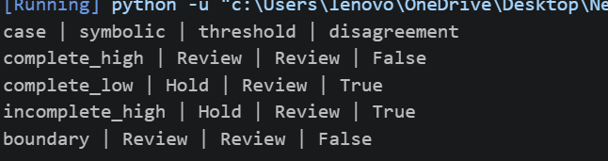

Compares.py.
